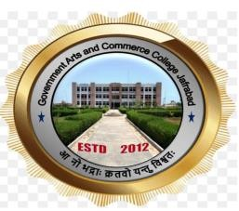

GOVERNMENT ARTS AND COMMERCE COLLEGE, JAFRABAD

‘STUDENT SENSITIZATION SEMINAR ON SSIP’

REPORT OF SEMINAR HELD ON 29TH FEBRUARY, 2024

COMMITTEE SSIP

Co-ordinator Principal
Prof Yamuna Panicker Dr. Viralkumar Shilu

Objective of the Seminar
The Student Startup and Innovation Committee of the college conducted the Seminar. The main objective of the seminar was to sensitize the students regarding startup and SSIP policy.

Resource Person
Dr. Amar Pandya – Faculty at Swaminarayan Institute of Management and IT, Porbandar

About the Seminar

At the beginning Prof. Yamuna Panicker-Coordinator, SSIP, welcomed the participants to the event and the programme, Thereafter, Dr. Viralkumar Shilu welcomed the guest speaker Dr. Amar Pandya.
Dr. Amar Pandya delivered the lecture with the help numerous interesting examples of existing startups. The session was very interactive wherein two-way communication was encouraged by the resource person.
Finally questions from the participants were welcomed. Prof Yamuna Panicker gave the Vote of Thanks
